**VISUALISATIONS IN “ R ”**

The question is

Choose any data set for your visualization from Vincent Arel Bundock dataset list: https://vincentarelbundock.github.io/Rdatasets/datasets.html.  
Plus, click [hereLinks to an external site.](https://support.rstudio.com/hc/en-us/articles/218611977-Importing-Data-with-RStudio" \t "_blank) on how to insert data to Rstudio.  
Using the data you selected, generate three types of visualization on the data set you have chosen.

Solution:

I have taken the data to create Visualization in R and I am sharing the line below for reference

|  |  |  |  |
| --- | --- | --- | --- |
| X | income | expenditure | |
| 1 | 751.6 | 672.1 |  | |
| 2 | 779.2 | 696.8 |  | |
| 3 | 810.3 | 737.1 |  | |
| 4 | 864.7 | 767.9 |  | |
| 5 | 857.5 | 762.8 |  | |
| 6 | 874.9 | 779.4 |  | |
| 7 | 906.8 | 823.1 |  | |
| 8 | 942.9 | 864.3 |  | |
| 9 | 988.8 | 903.2 |  | |
| 10 | 1015.7 | 927.6 |  | |
|  |  |  |  | |

<https://vincentarelbundock.github.io/Rdatasets/csv/AER/OlympicTV.csv>

1. Here is the code for ‘Basic Graphic in R’

CODE:

|  |
| --- |
| # Create a scatterplot of the data  plot(USConsump1979)  # Create a scatterplot of the data with a title  plot(USConsump1979, main="My Scatterplot") |
|  |

The plot() function in R is a generic function used to create a wide range of plots, including scatterplots. When called with a single argument that is a matrix or a data frame, plot() will create a scatterplot of each column against each other column. In other words, it will create a matrix of scatterplots, where the plot in row i, column j shows the relationship between the i-th column and the j-th column.

In the first line of code you provided, plot(USConsump1979) creates a scatterplot matrix of the columns in the USConsump1979 data frame.

In the second line of code, plot(USConsump1979, main="My Scatterplot"), the main argument is used to set the title of the plot. This creates the same scatterplot matrix as before, but with the title "My Scatterplot" at the top of the plot.

Note that the plot() function is a very basic plotting function and may not offer as much customization as other plotting packages in R, such as ggplot2. However, it is useful for quickly visualizing relationships between variables.

And the output is here.

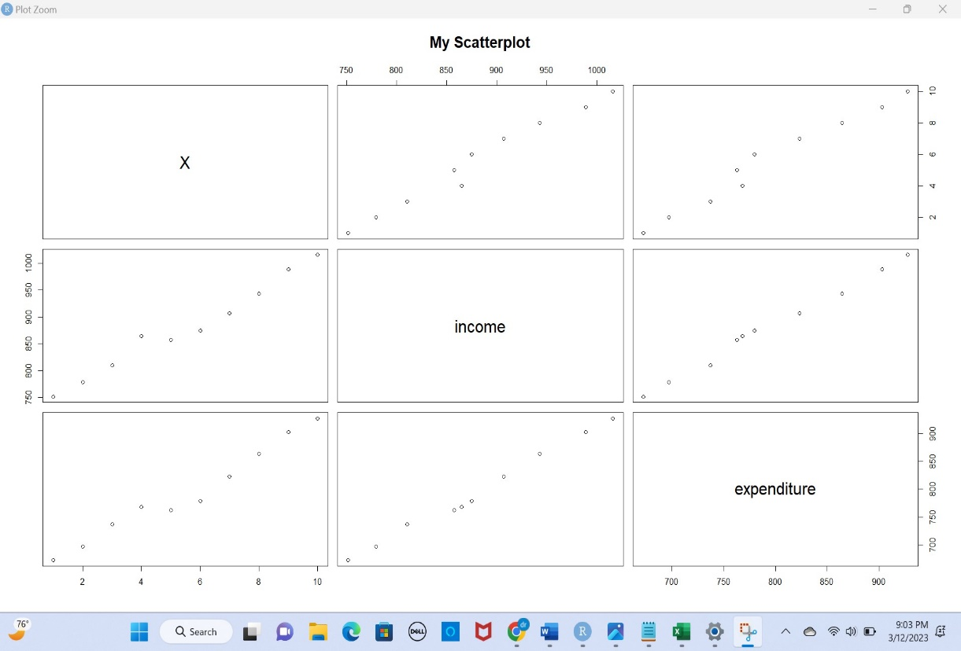

2. Here is the code for ‘Lattice Package in R’

CODE:

|  |
| --- |
| library(lattice) # load the lattice package  xyplot(expenditure ~ income, USConsump1979 = "Scatter Plot Example", xlab = "income values", ylab = "expenditure values") |

The code is using the xyplot() function from the lattice package to create a scatter plot of expenditure vs income using the USConsump1979 data frame. The function takes in the variables to plot on the x-axis and y-axis, and additional parameters to specify the data frame, and labels for the x-axis and y-axis. The ~ symbol is used to specify the formula, which in this case is expenditure ~ income, meaning expenditure on the y-axis and income on the x-axis. The lattice package provides a flexible system for creating a wide range of plots in R, and is often used as an alternative to the ggplot2 package.

The output is here

3. Here is the code for ‘ ggplot2 in R’

CODE

|  |
| --- |
| ggplot(data = data.frame(income = income, expenditure = expenditure), aes(x = income, y = expenditure)) +  geom\_point() +  labs(title = "usconsump1979", x = "income values", y = "expenditure values") |

The code used in the ggplot2 package to create a scatter plot of expenditure vs. income using the usconsump1979 dataset. Here's a step-by-step explanation of what the code does:

ggplot(data = data.frame(income = income, expenditure = expenditure), aes(x = income, y = expenditure)) creates a new ggplot object with the data.frame() function, which converts the income and expenditure vectors into a data frame with two columns. The aes() function is used to specify that the x-axis should represent income and the y-axis should represent expenditure.

geom\_point() adds a layer to the plot object, indicating that we want to use points to represent the data.

labs(title = "usconsump1979", x = "income values", y = "expenditure values") adds a title and labels for the x and y axes to the plot object.

Overall, the code creates a scatter plot of expenditure vs. income with the usconsump1979 dataset using the ggplot2 package.

The output Is here

